*Exploring the Impact of Image Downscaling Algorithms on Color Perception*

1st Bryan Myer Setiawan   
 *Computer Science Department*   
School of Computer ScienceBina Nusantara University Jakarta, Indonesia 11480  
 bryan.setiawan@binus.ac.id

4th Andry Chowanda  
 *Computer Science Department*  
School of Computer Science  
Bina Nusantara UniversityJakarta, Indonesia 11480  
achowanda@binus.edu 2nd Aura Kristian Sumowidjojo  
*Computer Science Department*   
School of Computer ScienceBina Nusantara University Jakarta, Indonesia 11480  
 aura.sumowidjojo@binus.ac.id

3rd Anderies  
 *Computer Science Department*   
School of Computer ScienceBina Nusantara University Jakarta, Indonesia 11480  
 anderies@binus.ac.id

***Abstract*—Several image downscaling algorithms have been developed in the past. However, most of them haven't been observed further towards the color perception after the downscaling process. This study performs several experiment tests to evaluate the results of several traditional and new image downscaling algorithms and the effect toward the preservation of color perception. To ensure an objective result, this study uses Quantitative Color Pattern Analysis (QCPA) to measure each algorithm’s performance and evaluate the effect towards the color perceptions. The experiments compare algorithms such as Bicubic Interpolation, Lanczos Resampling, Seam Carving, and Rapid Detail-Preserving Image Downscaling (RDPID) using Imagenette and DIV2K datasets. The evaluation metrics include average histogram similarity, dominant color shifts, and color scatter plots. Results indicate varying degrees of color information loss across algorithms, with Bicubic Interpolation and RDPID demonstrating better color fidelity compared to Seam Carving. This research highlights the color information loss due to the downscaling process through the chosen downscaling algorithms. Future studies could explore additional algorithms and evaluate their performance across different datasets and applications, further refining our understanding of color information loss in image downscaling processes and its impact towards computer vision tasks.**

***Keywords—Image downscaling, color perception, image downscaling algorithm, Quantitative Color Pattern Analysis***

# INTRODUCTION

Efficient image downscaling algorithms have become requisite to transform the ultra-high-resolution images into a much smaller dimension while preserving the key features such as the color perception [1], high contrast and crisp boundaries of the original image. This downscaling process becomes crucial when it comes to training algorithms to solve computer vision tasks because it directly influences the computational costs of the algorithms. Therefore, a middle line must be met to achieve significant size reduction and maintaining key features to the original image, particularly in terms of color accuracy. However, in the development of image classification algorithms, color is often overlooked. In addition, the exploration towards the impact of color perception after the image downscaling process has not been further explored yet.

Recent research about image downscaling can prove that certain high features still can be preserved at the downscaled result without any temporal artifacts. However, most of the experiments conducted require huge computational resources which can limit the practical use of real time. Recent research paper by Kanjar De and Marius Pedersenabout the impact of color on the robustness of deep neural networks found out that color information is an important factor in terms of computer vision tasks [2]. Hence, an experiment of several downscaling algorithms and analyzing the impact to the color perception could be the answer to improve both computer vision tasks and problems of reducing the dimensions of pictures while still preserving its key features.

To enhance comprehension of the impact of image downscaling towards color perceptions, we will conduct a series of experiments and compare the results quantitatively using Quantitative Color Pattern Analysis (QCPA) method [3]. First, we will explore 4 downscaling methods/techniques starting from downscaling the images from the DIV2K and Imagenette dataset into the classic Lanczos Filtering and Bicubic Interpolation and followed by the more recently proposed algorithms or techniques to show the relevance of our exploration on the color perception preservation when images are processed through the downscaling techniques. Then, both the downscaled and original image will be assessed through the QCPA, allowing us to see the loss of color of each downscaling technique proposed.

# LITERATURE REVIEW

A. Impact of Color

In the field of computer vision, algorithms or computers often require resizing of the input data or image, such as ultra-high resolution (UHR) images, to minimize the computing power requirements and maximize the accuracy of the output. [4] [2]. This method utilizes image transformation algorithms, widely known as downscaling algorithms when it comes to reducing the size of an image input data. These algorithms select a small number of specific colors or apply color palette reduction to downscale images, resulting in reduced loss of color information and affects the color perception of the image itself. Therefore, object detection and image classification tasks in computer vision that are directly affected through its input image and the information that it contains will theoretically be influenced in terms of its performance.

Buhrmester *et al*. [4] have conducted experiments on the publicly available cifar10 and cifar100 datasets, containing 32x32 pixel images of animals, to find the significance of color and image quality towards the accuracy of classification algorithms. They concluded that images in some classes, such as desert and animals, are highly dependent on the color information of an image.

Kanjar de and Marius Pedersen [2]have also conducted experiments exploiting the color information of the Imagenet datasets, pre-processed in 256x256 resolution and tested it through several popular CNN-architectures showing that this specific parameter has a relatively significant impact towards the accuracy and bias of classification algorithms. The experiment is performed using multiple *state-of-the-art* deep convolutional neural architectures of image classification. Through this experiment, they can conclude that Augmix technique and color information have a significant impact on robustness the training procedure and after observed in both EfficientNets(EfficientNetV1 and EfficientNetV2), higher resolution models are much more robust as the same trend (B7 has higher accuracy than B0 as well as V2L performs better than V2S) and NF-Nets. However, the disadvantage of this method is that it limits the effectiveness when color and contrast are important features in robustness due to it not using any form of color augmentation.

Gowda S. and Yuan C. [5]also found out that color spaces significantly impact image classification performance of deep learning algorithms like CNN by testing the existing algorithms with CIFAR-10, CIFAR-100 and ImageNet datasets, as well as proposed a new CNN model as a solution to address this problem.

This previous research led us to inquire on the effect of image downscaling algorithm towards the color information or perception of the image, which is the other end of pre-processing methods. [5]

B. Image Downscaling Algorithms

Image downscaling [6] [7] [8]aims at reducing resolution at minimum loss of quality. It is somewhat related to image compression but in lossy compression, some features or quality are irreversibly lost. While there is still limited research regarding the impact of downscaling algorithms on color perception of images. Several research [2] concludes that image downscaling algorithms can have significant impact on color accuracy and quality of resulting image.

Starting with the classical algorithm of image transformation, the Lanczos filtering was introduced and designed to reduce the amplitude of aliasing in the downscaled image through filtering the image before resampling it, effectively removing high-frequency components that would cause the aliasing [9]. This filtering process helps maintain the integrity of the original image when downscaling it.

Other than Lanczos filtering algorithm, traditional image downscaling method that was commonly used was Bicubic Interpolation [7]. Bicubic interpolation-based image downscaling was widely used when a high-quality result is expected after the image downscaling process. However, this algorithm can still lead to aliasing issues due to the loss of high-frequency details in the downscaling process. In addition, the most recently developed image-downscaling algorithms uses Bicubic Interpolation as the base comparison of their results [10] [11] [12].

Avidan and Shamir [13] proposed a seam carving image operator method that supports content-aware image scaling for both image downscaling and upscaling. The seam carving process includes carving out or inserting seams in an image to change the image’s size while preserving the details. This method and result prove in an effective image detail preservation. This method can be used for image content enhancement or object removal. In addition, other research about seam-carving have been concluded by Han *et al.* [14]*.* Han *et al.* did a wavelet analysis which addresses the limitations of conventional seam carving techniques. This research also results in the downscaled image to still preserve the important semantic information and the shape of main objects in the scene.

Kim, S. and Kim, T. [15] proposed an enhanced version by removing the noise amplification of the previously proposed Rapid, Detail-Preserving Image Downscaling (RDPID) [16]. They utilized a two-step one-dimensional inverse joint bilateral filtering and an area pixel model to achieve a fast downscaling while maintaining the important features of the original image. However, the paper only suggests superiority over existing techniques, a more comprehensive evaluation using quantitative metrics like PSNR and SSIM is not explicitly mentioned.

Due to the filter not being able to adapt to the content of images when downscaling, a content-adaptive technique [17] was proposed later to overcome this problem through adapting the shape and location to achieve better downscaling images. SSIM or Structural Similarity Index Method [18] was later introduced in response to the rising improvement of content-adaptive technique and serves as the perceptual image quality matrix. It compares two images by calculating the differences in luminance, contrast, and structural information and gives either a score of 0 or 1 to represent whether the two images are identical or completely different. This method was widely used and useful as it can help identify the algorithm that best preserves the structural information and visual quality of the original image.

Recent research of downscaling algorithm was proposed by Pack C. et al. [19] in 2023, a method for adaptive image downscaling that is guided by perceptual cues to enhance the performance of semantic segmentation tasks on large document images, focusing on preserving important features such as crisp boundaries and high contrast of the image. They also demonstrated further testing by using three different training scenarios: stand-alone, image-pyramid, and augmentation. As a result, the proposed method was proven to be effective when tested into a deep learning-based document image segmentation pipeline and compared to a few other downscaling methods like Lancsoz [9].

C. Quantitative Color Pattern Analysis

Quantitative Color Pattern Analysis (QCPA) [3] is a comprehensive approach to the study and analysis of color patterns through statistical data. QCPA dynamic framework can be viewed to solve the quantitative and qualitative limitation of existing color pattern analyses by combining digital photography and visual modeling. QCPA methods include modeling of spatial faculty using Fast Fourier transform of Gaussian filter, image smoothing and edge reconstruction using receptor noise limited ranked filter, image segmentation using receptor noise limited clustering and naive bayes clustering, pattern analysis, and data visualization. These quantitatively scaled workflow can’t be considered as a ‘perfect’ solution; however, it can provide an idea on how to scale different elements of vision modeling and color patterns analysis through existing methods.

# PROPOSED METHOD

1. Dataset

Generally, datasets used to train classification or object detection algorithms already contain relatively small sized images with pixels around 32x32 up to 256x256 to lower the computing power needed. In this experiment we will utilize 2 kinds of dataset. Firstly, the DIV2K dataset, containing 1000 2K resolution images divided into 3 subsets of train, validation, and test sets. This dataset also contains low-resolution images produced using bicubic_x2, bicubic_x3, and bicubic_x4 downscaling algorithms. Due to this dataset providing both high- and low-resolution images, it is a perfect fit towards our experiment in finding the impact of downscaling algorithms on color perception, in which we can use the already downscaled images using the bicubic algorithm or use the raw high-resolution image and downscale it using other image downscaling algorithm to generalize the result in loss of color information.

In addition, we also utilize the Imagenette dataset which is a subset of the larger ImageNet dataset. This dataset contains 13394 images spanning 10 different classes from diverse sources and resolutions and divided into 3 subsets of train, validation, and test sets. For training and evaluation, the images are resized into a 224x224 pixels dimensions to align with CNN input sizes and ensure consistency. This dataset is considered as one of the best resources for training, validating, and testing image classification models which have limited computational resources.

1. Image Downscaling Algorithm

As previously discussed in the literature review, several downscaling algorithms will be used to measure the significance of color information loss of the downscaled images to reduce bias and generalize the results. This downscaling algorithm includes [9] [7] [13] [14] [16]:

1. Lanczos resampling
2. Bicubic interpolation
3. Seam Carving
4. Rapid, detail-preserving image downscaling (RDPID)

However, in this experiment we focus on the x1/5 image downscaling in size due to the normal training input size of classification algorithms being around 32x32 up to 224x224 pixels.

1. Data Collection and Analysis

In this research, we will extract color features from the original and downscaled images to compare the color information loss using methods adapted from the proposed method called **Quantitative Color Pattern Analysis (QCPA)** [3] by Cedric P. van den Berg and Jolyon Troscianko. Specifically, we will employ color histograms to measure the distribution of colors, providing insights into the preservation or loss of color information during downscaling. Additionally, we will analyze dominant color shifts using pie charts to visualize changes in the most prevalent colors between the original and downscaled images. Furthermore, color scatter plots will be utilized to compare the spread and density of color distributions, helping to identify any significant deviations or clustering effects caused by the downscaling process. These combined methods offer a comprehensive evaluation of the color fidelity and transformation occurring due to the downscaling techniques.

1. RESULT AND DISCUSSION

Based on the experiment results, color loss can be proven through the average histogram similarities which includes, Bicubic Interpolation has the highest average histogram similarity for both Imagenette and DIV2k Dataset, and Seam Carving has the lowest average histogram similarity for both the dataset as well. Other than through the average histogram similarity, the shift of dominant color can also be viewed as an indicator of color loss which may affect the accuracy of algorithms for image tasks like CNN.

* 1. Qualitative Approach of Image Downscaling

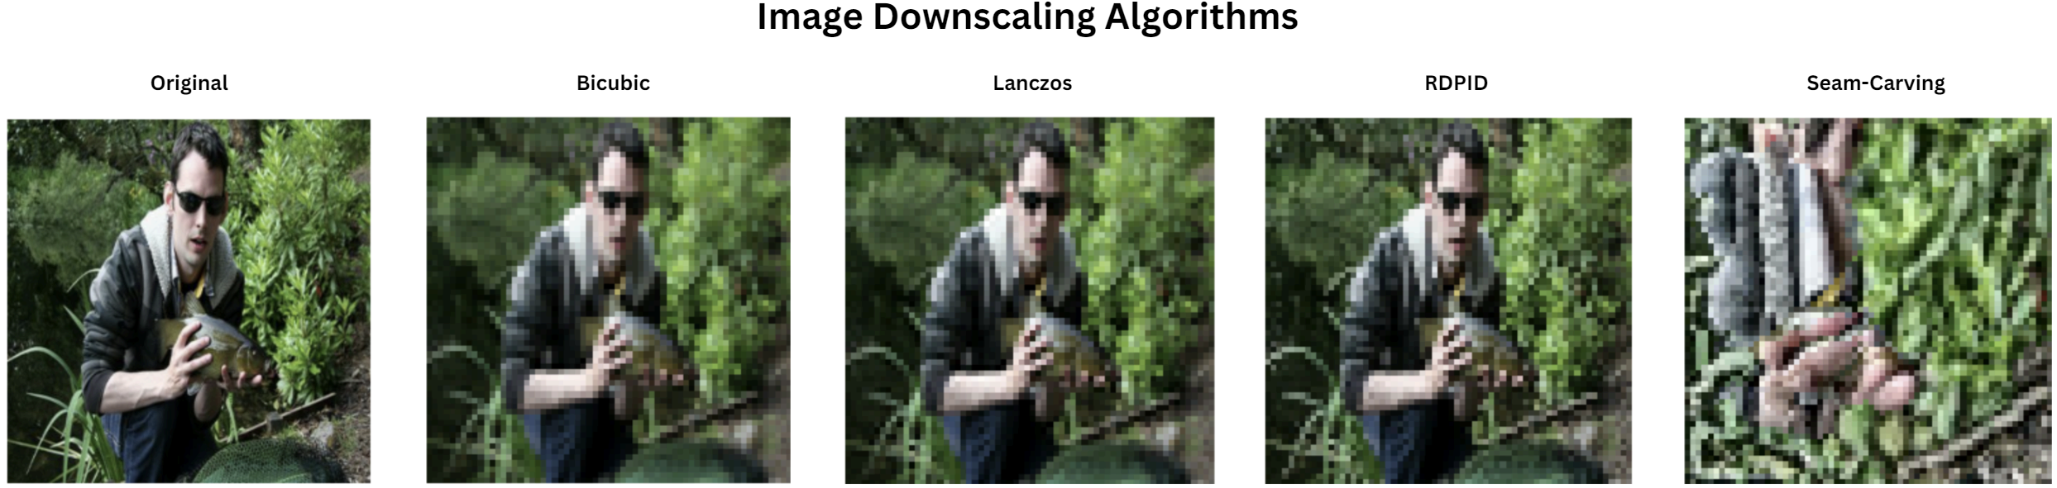





**Figure 1:** *Downscaled Imagenette visualization.*

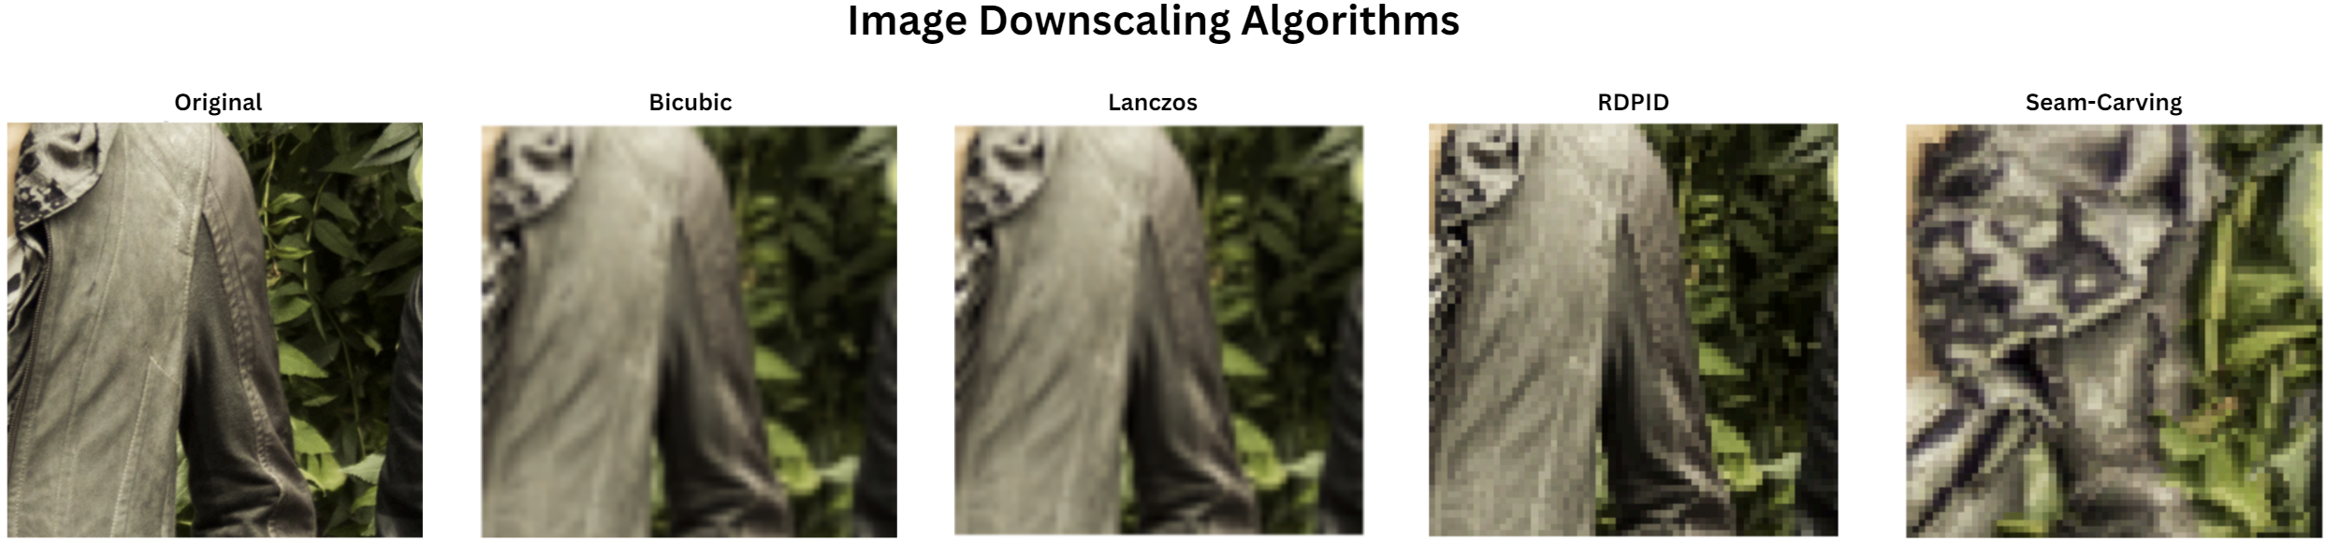



**Figure 2:** *Downscaled DIV2K visualization.*

Figure 1 presents a comparative visualization of image downscaling results using the original image, and four other image downscaling results: Bicubic Interpolation, Lanczos Resampling, Seam Carving, and Rapid Detail-Preserving Image Downscaling (RDPID). Each result demonstrates unique upside and downsides as below. The original image serves as a benchmark to assess the retention of image detail and color accuracy.

* **Bicubic Interpolation**: As shown in Figure 1 and 2, Bicubic Interpolation has the best visual representation with a relatively smooth result. However, this comes at the cost of losing some sharpness and details shown in the noticeable blurring around edges and fine structures, in addition color loss can be seen.
* **Lanczos Resampling**: Lanczos Resampling has a sharper edge preservation compared to Bicubic Interpolation. Due to this fact, Lanczos is able to maintain the overall image sharpness edge definition effectively. However, this method also results in ringing artifacts, visible as slight halos around high-contrasts edges.
* **Seam Carving**: In terms of visual representation, Seam Carving does not have the best result as can be seen in both Figure 1 and 2. This fact can be caused by the algorithm’s priority to preserve important content and structures by removing less significant pixels. As a result, noticeable artifacts and a less natural appearances can be seen through areas in which the content has been artificially stretched or compressed. In addition, this method is considered useful in content-aware applications but may not be suitable for all types of imagery.
* **Rapid Detail-Preserving Image Downscaling (RDPID)**: The result produced by RDPID shows a high level of detail retention and color fidelity. Overall, RDPID produces the best overall result, producing an optimal balance between edge preservation, color fidelity, and minimal artifacts. As seen in both Figure 1 and 2, RDPID maintains the integrity of fine details and minimizes color distortions, making a robust choice of downscaling.

This structured discussion provides a comprehensive analysis of the results. However, this is considered as a qualitative/ subjective approach with no statistical approach considered.

* 1. Quantitative Approach of Image Downscaling

Examining the color information loss further, we adopted the QCPA method and specifically chose color histogram, dominant color shifts and color scatter plot as the medium.

* + 1. **Color Histogram**

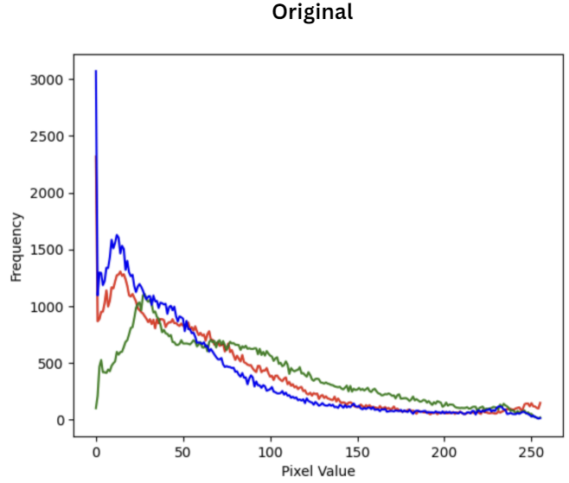

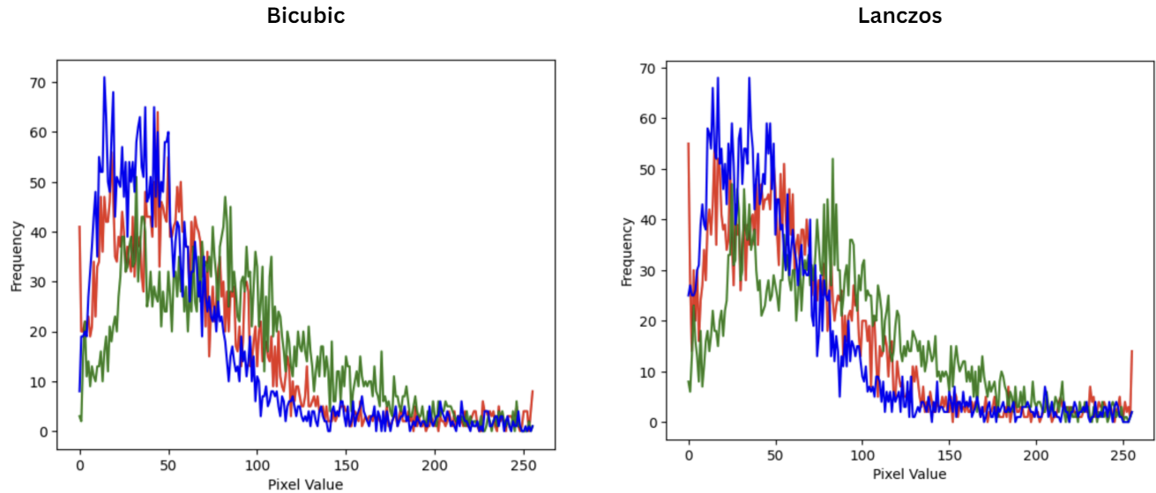

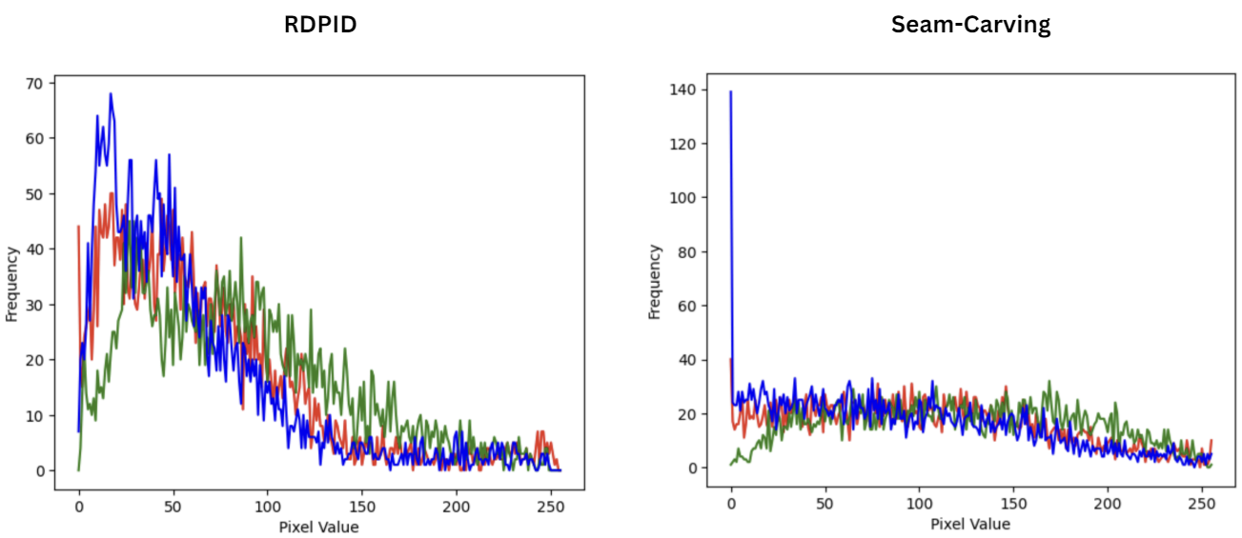

**Figure 3:** *Downscaled Imagenette Color Histogram*

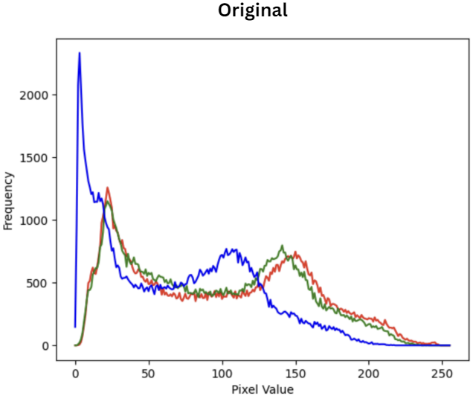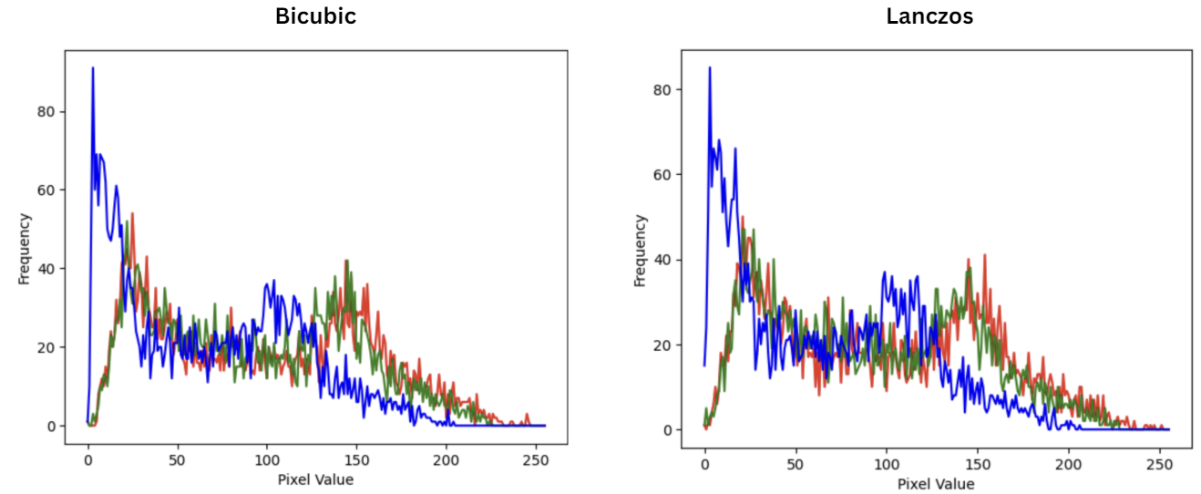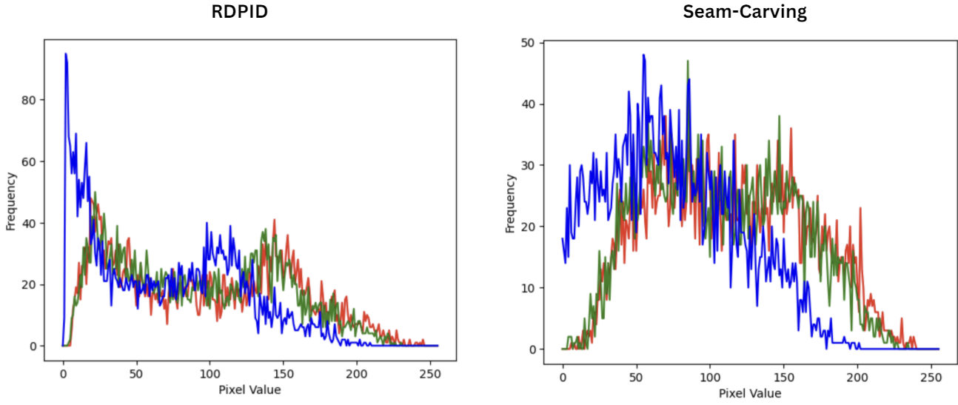

**Figure 4:** *Downscaled DIV2K Color Histogram*

TABLE I

Average Histogram Similarity Comparison Between Downscaling Algorithms with Imagenette Dataset

|  |  |
| --- | --- |
| Downscaling Algorithm | Average Histogram Similarity |
| Bicubic Interpolation | 0.8792103722198236 |
| Lanczos Filtering | 0.7681326973002135 |
| Seam Carving | 0.20821474274309235 |
| Rapid, Detail-Preserving Image Downscaling (RDPID) | 0.8159674241527768 |

TABLE II

Average Histogram Similarity Comparison Between Downscaling Algorithms with DIV2K Dataset

|  |  |
| --- | --- |
| Downscaling Algorithm | Average Histogram Similarity |
| Bicubic Interpolation | 0.6572319418783961 |
| Lanczos Filtering | 0.6509477960057188 |
| Seam Carving | 0.4876944090873246 |
| Rapid, Detail-Preserving Image Downscaling (RDPID) | 0.6469631973092833 |

Through the color histogram provided in Figure 3 and 4, we evaluate the effectiveness of the four-image downscaling method the Imagenette and DIV2K datasets quantitatively. Color Histogram provides a graphical representation of the distribution of colors across different color channels (mainly red, green, and blue) in an image to understand the impact of color information preservation. In addition, from table 1 and table 2, the average histogram similarity represents the numerical representation of the color histogram showin. The details of each downscaling are below.

**Bicubic Interpolation** has a histogram characteristic of a smoother and narrower histograms compared to the original images. Having the highest score of average histogram similarity of 0.87921 from the Imagenette Dataset and 0.65723 from the DIV2K Dataset, this indicates that Bicubic Interpolation preserves the color information from the original image well.

**Lanczos Resampling** produces a histogram characteristic of a broader and exhibit more peaks compared to Bicubic result. This indicates a better preservation of edges and other fine details. This algorithm also produces an average histogram similarity of 0.76813 from the Imagenette Dataset and 0.65095 from the DIV2K Dataset. In addition, the lower histogram similarity score introduces the changes to the color distribution from the original image.

**Seam Carving** displays a histogram that shows significant deviations with huge number of certain color intensities as well as the unpredictable patterns in the distribution of those color intensities. This algorithm has the lowest averga histogram similarity among other algorithms of 0.20821 through Imagenette dataset, and 0.48769 through DIV2K Dataset. The low similarity score reflects the substantial removal/ shifts in color intensity which are captured in the histogram shown in Figure 3 and 4.

**Rapid Detail-Preserving Image Downscaling (RDPID)** has a histogram characteristic that matches identically to the original. This method proves the fact the RDPID preserves both the color intensity and range resulting in a minimal color deviation. With an average histogram similarity score of 0.81597 through Imagenette Dataset and 0.64696 through DIV2K Dataset, RDPID still has a slightly lower score than Bicubic. However, this indicates an the algorithm’s ability in balancing detail retention with maintaining the original color intensities.

* + 1. **Dominant Color Shift**

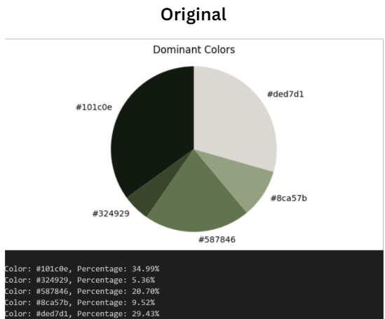

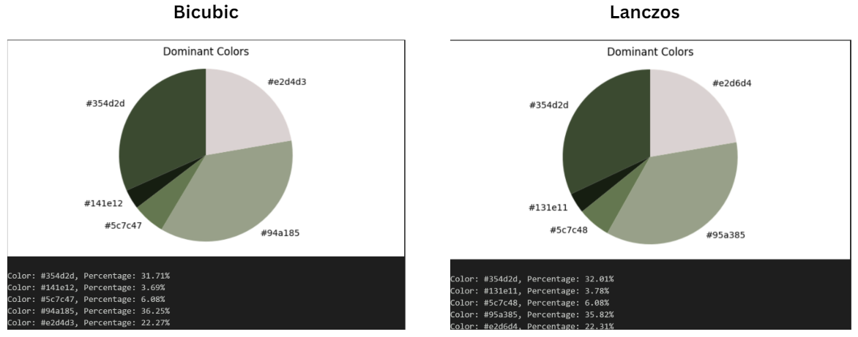

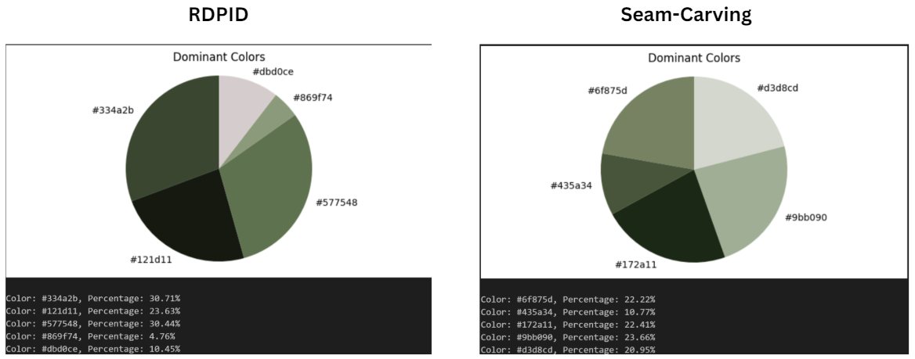

**Figure 5:** *Downscaled Imagenette Dominant Color Pie Chart*

Dominant Color Shift analysis examines the primary colors changes in the images comparing the original and downscaled results. Through this experiment, this shift is visualized using pie charts that displays the distributions of the top five most dominant colors from an image. Changes in the distribution may provide an insight into how each method affects the overall color percentages of an image.

**Bicubic Interpolation** has a color shift characteristic of a slight shift towards blues and green as being a more dominant color. This color shift indicates a loss of some vibrancy in warmer color hues which may indicate a less preferred algorithm when color warmth is crucial. An example of this finding can be seen through Figure 5, which the original image has the color: #101c0e with the percentage of 34.99% shifting to a greener dominant color: #94a185 with the percentage of 36.25%.

**Lanczos Resampling** maintains a color distribution that is somewhat like the original. However, a slight increase of certain color hues can be seen such as in red and green. This indicates that a minor alteration in the overall color balance which may have an effect of certain hues being enhanced but can also cause problematic results respectively when a precise color accuracy is needed. This can be seen through the sample in Figure 5 in which the downscaled result shifts in a greener dominant color: #95a385 with the percentage of 35.82%.

**Seam Carving** introduces more noticeable shifts in the dominant colors compared to the other algorithms. Often favoring different color hues for different images, this may result in an uneven distribution. In addition, this algorithm concludes that Seam Carving can be considered as a less reliable option to maintain the original color balance. An example is provided in Figure 5 in which the downscaled result shifts in a greener dominant color: #9bb08f with the percentage of 23.56%.

**Rapid Detail-Preserving Image Downscaling (RDPID)** maintains a minimal color shift after being downscaled from the original image and most color hues are in a small range of difference. This indicates that RDPID effectively preserves the overall color balance making this algorithm suitable for image downscaling algorithm that require high color fidelity. An example is provided in Figure 5 in which the downscaled result shifts in a greener dominant color: #334a2b with the percentage of 30.71%.

* + 1. **Image Color Scatter**

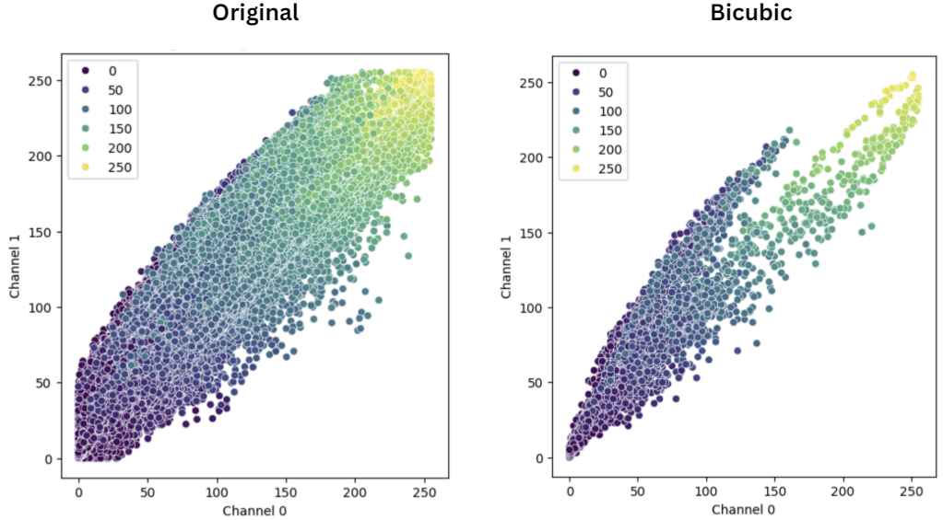

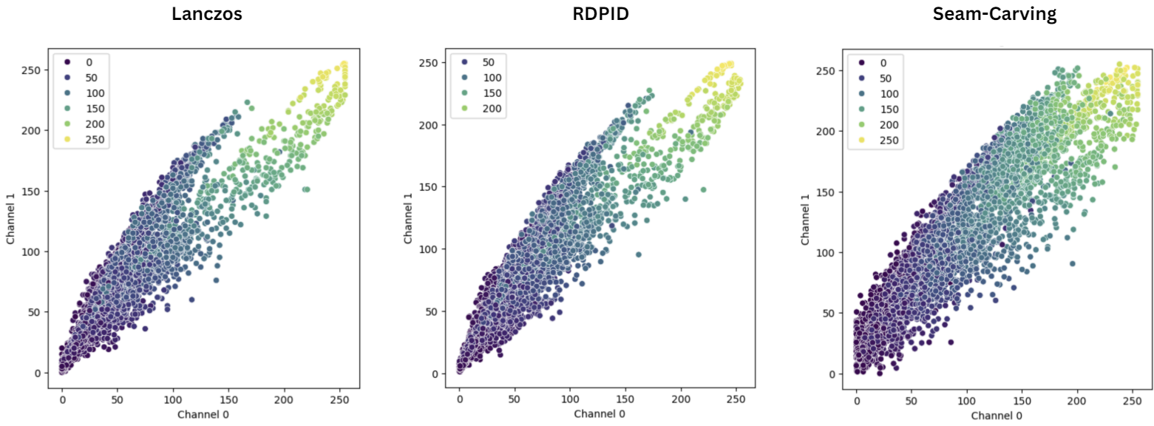

**Figure 6.** *Downscaled Imagenette color scatter plot*

Image color scatter provides a plot representation of the distribution and clustering of image colors. Each plot represents the corresponding color, and the position is determined by the color’s RGB values. This plot may help analyze how various downscaling algorithms may affect the spread and clustering of colors resulting in a diverse color distribution.

**Bicubic Interpolation** has the scatter plot characteristic of maintaining the overall color structure of the original image but results in a more compact color distribution. As shown in Figure…, the original image displays a broad and even distribution of colors with points scattered across the RGB spectrum. In addition, the Bicubic Interpolation results in a more compact distribution, suggesting that Bicubic Interpolation blends most of the colors closely together, indicating a loss of some color variation and more uniform color palette.

**Lanczos Resampling** displays the scatter plot characteristics of maintaining a broad spread with a more distinct clusters, like the original. The color distribution is well preserved with only slight enhancements in certain areas. The algorithm retains the natural color variations while enhancing the image edges making it more suitable for HR images with critical details.

**Seam Carving** presents the scatter plot characteristic of uneven distribution and varied cluster sizes. Since this method focuses more on content leads to a significant alteration in color diversity and distribution, the scatter plot also reflects the uneven color preservation respectively. Overall, Seam Carving is less suitable for downscaled results that requires a consistent color representation.

**Rapid Detail-Preserving Image Downscaling (RDPID)** represents the scatter plot characteristics of a close match to the original image. The plot represents a wide and even color distribution. Clusters are also well-preserved indicating a minimal color loss. This indicates that RDPID will be ideal where the downscaled result requires a better image quality and color fidelity.

1. CONCLUSION

Our analysis using methods adapted from QCPA revealed notable differences in color information loss or shifts after each downscaling process. Through this experiment, we also obtained how various downscaling algorithms affect color fidelity. Bicubic Interpolation, despite achieving the highest average histogram similarity, exhibited some color loss and a more uniform color palette. Lanczos Resampling preserved edges well but introduced slight color distortions. Seam Carving, while preserving important content, showed significant deviations in color distribution, making it less reliable for maintaining color balance. Rapid Detail-Preserving Image Downscaling (RDPID) consistently demonstrated high detail retention and minimal color loss, making it the most robust method in our study for preserving both detail and color fidelity.

Our experiments demonstrate a clear and measurable loss of color information during the downscaling process across different algorithms. The average histogram similarity results indicate that Bicubic Interpolation and Rapid Detail-Preserving Image Downscaling (RDPID) preserve color information relatively well, with Bicubic Interpolation showing the highest similarity scores. In contrast, Seam Carving exhibits the most significant color loss, as evidenced by the lowest histogram similarity scores. The analysis of dominant color shifts and color scatter plots further supports these findings, revealing noticeable shifts and changes in color distribution, particularly for Seam Carving. These results highlight the varying degrees of color fidelity retention among the downscaling methods, with Bicubic Interpolation and RDPID performing better in maintaining color integrity, while Seam Carving shows substantial color information loss. This significant color alteration in Seam Carving could have implications for its suitability in applications where color accuracy is critical. Overall, our experiments underscore the importance of selecting appropriate downscaling algorithms based on the desired balance between detail retention and color fidelity.

This experiment can be viewed as a base for several other future experiments that may direct and develop this experiment. More algorithms can be tested such as using content adaptive image downscaling algorithm, perceptually based downscaling algorithm, scale-arbitrary invertible image downscaling algorithm, and others. In addition, the models provided can be tested in several Convolutional Neural Networks (CNNs) which may prove the significance in the real use cases.

# References

|  |  |
| --- | --- |
| [1] | K. R. G. Christoph Witzel, "Color Perception: Objects,," *Annual Review of Vision Science,* vol. 4, pp. 475-499, 2018. |
| [2] | M. P. Kanjar De, "Impact of Colour on Robustness of Deep Neural Networks," *Proceedings of the IEEE International Conference on Computer Vision,* pp. 21-30, 2021. |
| [3] | J. T. J. A. E. N. J. M. K. L. C. Cedric P van den Berg, "Quantitative Colour Pattern Analysis (QCPA): A comprehensive framework for the analysis of colour patterns in nature," *Methods in Ecology and Evolution,* vol. 11, no. 2, pp. 316-332, 2020. |
| [4] | B. V. D. D. e. al., "Evaluating the Impact of Color Information in Deep Neural Networks," *Lecture Notes in Computer Science,* vol. 11867, p. 302–316, 2019. |
| [5] | C. Y. Shreyank N Gowda, "ColorNet: Investigating the Importance of Color Spaces for Image Classification," *Lecture Notes in Computer Science,* vol. 11364, p. 581–596, 2019. |
| [6] | S. M. K. K. P. C. Y. P. C. L. J. L. Jaehwan Kim, "HIGH-FREQUENCY PRESERVING IMAGE DOWNSCALER," *Proceedings - International Conference on Image Processing, ICIP,* 2021. |
| [7] | Z. C. Wanjie Sun, "Learned Image Downscaling for Upscaling Using Content Adaptive Resamapler," *Li WNi LLi ZDuan SWu H,* pp. 4027-4040, 2020. |
| [8] | C. A. B. Dragos Dumitrescu, "A study of image upsampling and downsampling filters," *Computers,* vol. 8, no. 2, p. 30, 2019. |
| [9] | H. D. Simon, "The Lanczos Algorithm With Partial Reorthogonalization," *Mathematics of Computation,* vol. 142, pp. 115-142, 1984. |
| [10] | G. R. W. T. Donatella Occorsio, "Lagrange–Chebyshev Interpolation for image resizing," *Mathematics and Computers in Simulation,* vol. 197, pp. 105-126, 2022. |
| [11] | D. Z. J. Z. R. X. a. Yongbing Zhang, "Interpolation-Dependent Image Downsampling," *IEEE TRANSACTIONS ON IMAGE PROCESSING,* vol. 20, pp. 3291-3296, 2011. |
| [12] | T.-H. W. C.-T. C. Wei-Chen Wu, "Edge Curve Scaling and Smoothing with Cubic Spline," *J Sign Process Syst,* vol. 78, pp. 95-113, 2015. |
| [13] | a. A. S. Shai Avidan, "Seam Carving for Content-Aware Image Resizing," *Seminal Graphics Papers: Pushing the Boundaries,* vol. 2, no. 3, pp. 609-617, 2023. |
| [14] | K.-S. C. T.-S. W. S.-H. C. a. S.-J. K. Jong-Woo Han, "WAVELET BASED SEAM CARVING FOR CONTENT-AWARE IMAGE RESIZING," *2009 16th IEEE International Conference on Image Processing (ICIP),* pp. 345-348, 2009. |
| [15] | T. S. K. Su Hyon Kim, "A New Rapid and Detail-Preserving Image Downscaling Without Noise Amplification," *IEEE Access,* vol. 10, pp. 107032 - 107042, 2022. |
| [16] | M. W. S. C. A. S. G. M. G. Nicolas Weber, "Rapid, Detail-Preserving Image Downscaling," *ACM Transactions on Graphics,* vol. 35, no. 6, pp. 1-6, 2016. |
| [17] | Johannes Kopf, Ariel Shamir, Pieter Peers, "Content-Adaptive Image Downscaling," *ACM Transactions on Graphics,* pp. 1-8, 2013. |
| [18] | A. C. B. Ming-Jun Chen, "Fast structural similarity index algorithm," *Journal of Real-Time Image Processing,* vol. 6, p. 281 – 287, 2011. |
| [19] | L. K. S. E. L. Chulwoo Pack, "Perceptual cue-guided adaptive image downscaling for enhanced semantic segmentation on large document images," *International Journal on Document Analysis and Recognition,* pp. 1 - 17, 2023. |